*** If you are not comfortable completely removing your dash, flushing your coolant, or working around airbags then you should stop now and seek assistance or take your truck to a reputable repair shop. ***

By: Michael Staszewski - michael.staszewski@gmail.com

Special thanks to F150Online.com and member AlanT who posted the original instructions that I followed. The following instructions are a combination of those provided by him along with real photos that I took during reassembly. The original thread by AlanT can be found here...

http://www.f150online.com/forums/hvac/215665-i-replaced-my-blend-door-heater-core-happy-ending.html

NOTE: I no longer own the truck I performed this on, but will try to answer any questions you have to the best of my memory which has likely been diminished a little based on beer consumption. :-)

Purpose

Heater core replacement guide

Vehicle

2002 Ford F150 SuperCrew XLT
5.4L motor
4x4
Automatic transmission

The steps should generally be the same for all 1997-2003 Ford F150 trucks although the placement and number of fasteners and electrical connectors may differ slightly.

Prerequisites

- You must know how to flush your radiator and replace your coolant.
- You must also be comfortable working with basic hand tools in confined spaces.
- You must be comfortable disassembling your dash and disconnecting many electrical connections.
- You must be physically capable of twisting and cramming yourself into tight spots.
- You must also be physically able to lift a moderate amount of weight as the dash assembly is a little heavy. It should be handled gently to prevent any damage to it and yourself. Being able to support and maneuver 60 lbs. should be sufficient.
- You should allow plenty of time to complete this job. It took me close to 12 hours, but I documented the procedure, replaced both radiator hoses, the thermostat, and did an exceptional job of flushing the cooling system. If you are doing the heater core only and already know how to flush and replace your coolant then you can probably finish this in 6-8 hours.

Parts list
- Heater core
- Replacement o-rings and clips that secure the two hoses to the inlet and outlet tubes on the heater core
- Foam tape to wrap the new heater core
- Everything needed to perform the coolant change

The parts for the heater core (1, 2, and 3 above) will be no more than $100. I purchased those parts, 2 new radiator hoses, 8 gallons of distilled water, 3 gallons of premium coolant, radiator flush chemicals, coolant additive, and a new thermostat for $220.

Tools required

Although it’s best to have a good assortment of hand tools for any project, the following list of tools is what I used.

- 1/4 inch ratchet sets with assorted sockets (deep sockets too), extensions, and a universal joint (7 mm, 8 mm, 10 mm, and a small standard socket (5/16th inch?!?) used)
- 3/8 inch ratchet set with assorted sockets (deep sockets too) and extensions (10 mm and 13 mm sockets used)
- Special tool from Ford for removing the hoses connected to the inlet and outlet pipes on the old heater core. This is optional! See the Tips section.
- Screwdriver set
- Flashlight
- Magnetic tool for recovering dropped sockets and screws
- Several feet of twine, string, heavy weight fishing line, or an old shoelace for tying to the antenna cable

Tips
- Use a large box to hold all non-fastener parts (i.e. all trim parts, steering column reinforcement, etc.)
- Use sandwich bags to store all fasteners and small parts removed. Use a marker to label the bag with the step number. If a step says to remove 6 screws then remove them and place those screws and only those screws in a bag. Write the step number on the bag. This will ensure that you have no leftover parts when you are done and that you will not lose parts.
- Using electrical tape, place a couple of wraps around a flathead screwdriver and use that to pry trim panels up that are just held in by snaps. This will ensure that you don’t scratch the trim panels.
- Have your twine/string/shoelace within reach when you remove the antenna. You will need it immediately.
- A rotary tool (Dremel) with cutoff wheels, reciprocating saw, or small hacksaw may be used instead of the special tool from Ford for disconnecting the hoses from the old heater core.
- A cordless drill can speed things up quickly, but be careful when reassembling so that you don’t strip screws by over tightening them.
- This job can be performed with one person, but a second person is always helpful. I’ve found that having someone hold the heater core while I reconnect the hoses helps.
- Set parking brake and set chock blocks to prevent the truck from accidentally rolling away on you.
- Print these instructions and have a pen handy. You should note anything that differs for your vehicle for a given step so that you don’t forget to reassemble something.
- A camera is also a handy tool to document something before you disassemble it. This will ensure that you have a reference should you forget how something was originally installed.

Procedure
- With vehicle on, turn the temperature setting to a cool setting, not max cold. The 9:00 position on the temperature dial is perfect. This will make your life a lot easier when removing the blend door later on.
- Disconnect the negative and positive cables from the battery and wait a couple of minutes to deplete any backup power supplies like those used by the airbags.
- Drain the radiator and block of all coolant.
- Remove the antenna (NOTE: have your string ready now)
  - Carefully pry up on the black plastic cap that covers the antenna mounting plate
  - Remove the 3 screws
  - Carefully pull up on the antenna to expose the antenna cable
  - Tie your string to the antenna cable so that you can later recover it. It will fall into that hole!
  - Remove the cable from the antenna, it just plugs in like an RCA plug.

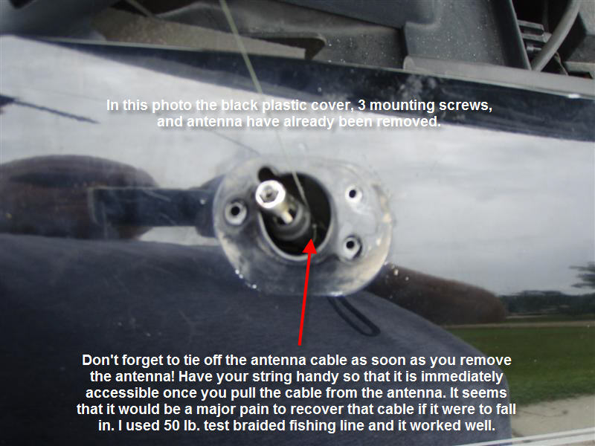

- Carefully pry the steering column top cover (B) to release the clips (A).
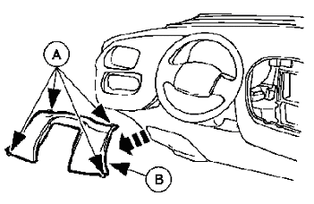
- Pull the fuse panel door (B) to release the clips (A) and remove the fuse panel door completely.
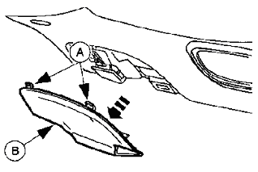
- Remove the hood latch release handle.
  - Remove the two screws
  - Pull the handle down and away from the dash
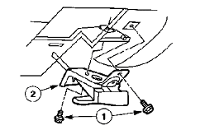
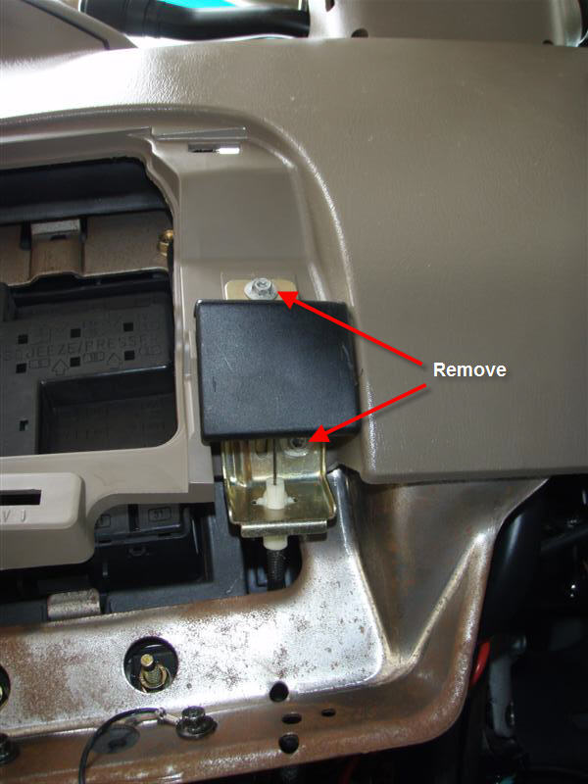

- Remove the parking brake release handle
  - Remove the two screws
  - Pull the handle down and away from the dash
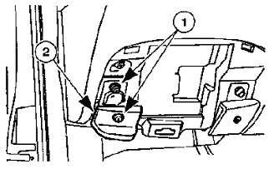
- Remove the floor duct cover by carefully prying the clips. This illustration is a bit off. The 2002 does not have a clip on the front. It has two clips on the driver side and one on the passenger side. Just grab behind the panel on the driver side and gently pull towards the driver side door. Do the same for the passenger side.
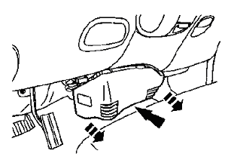
- Remove the diagnostic port.
  - Remove the two screws that hold the diagnostic port to the steering column cover.
  - Remove the backing plate on the port by gently prying or pulling it off.

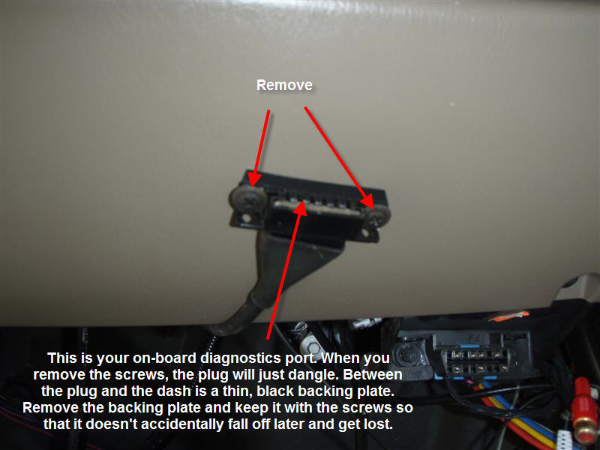

- Remove the instrument panel steering column cover.
  - Remove the 6 screws. The two screws at the bottom are in metal and are 8 mm, the remaining 4 are in plastic and are 7 mm. Some models may have a ground wire attached to one of those screws in metal. Be sure to replace this wire during reassembly if it is present.
  - Remove the panel
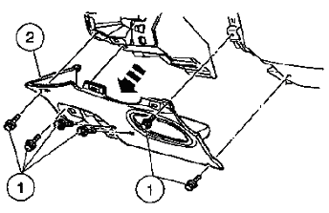
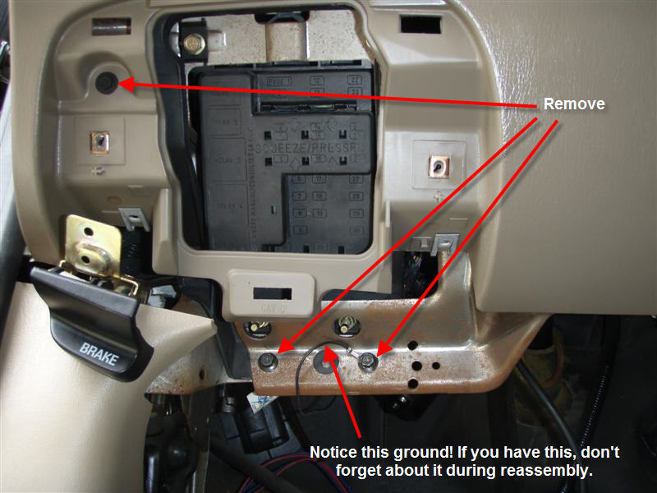

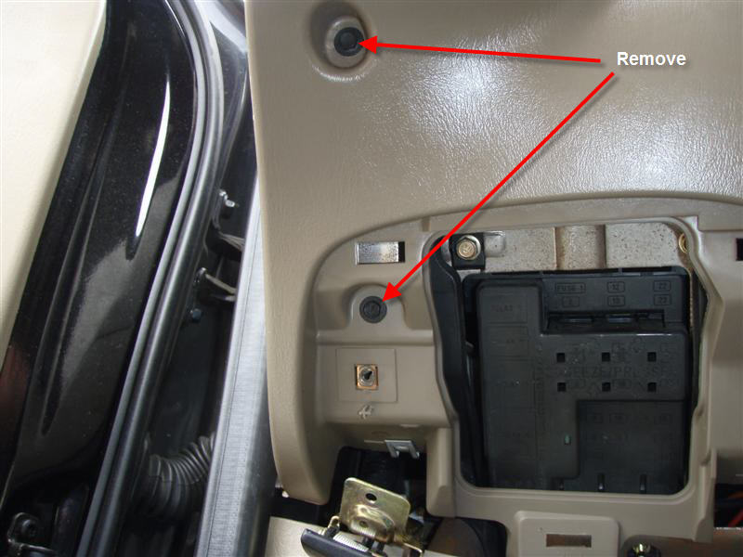

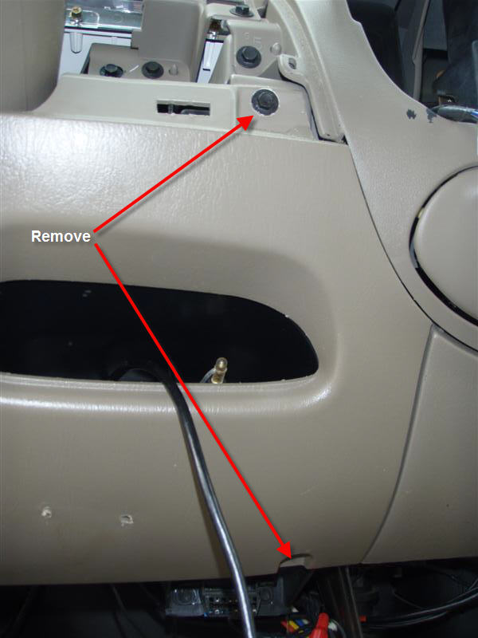

- Remove the scuff plates from the driver and passenger side.
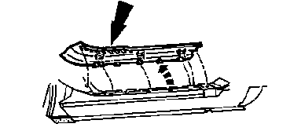
- Remove the cowl side trim panels from the driver and passenger side. You’ll need to partially remove the black seal that wraps around each door opening to do this step. I recommend completely removing the seals at this time as they will most certainly need to come out later.
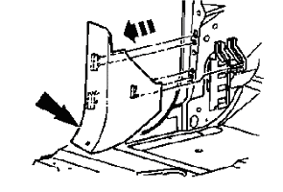
- Remove the assist handles on both the driver side and passenger side A-pillars. You will need to pop out the covers first that conceal the nuts that hold it on. Warning: The exposed threaded rods that are left after the handles are removed seriously hurt when you bump your head on them. I didn’t cover them with anything, but have several cuts that suggest that I should have. After completing the next step, find something to wrap around them like bits of a rag or something. Tape them up good and you should prevent any real damage to your head in the future.
- Remove the trim panels that cover the driver side and passenger side A-pillars.
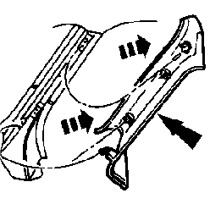

- Disconnect the brake on/off (BOO) switch connector that is located just above the brake pedal on the side closest to the driver side door.
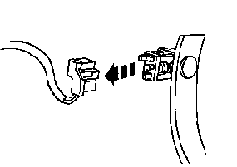
- Disconnect wires, grounds, and antenna cable behind the cowl side trim panel on the passenger side.
  - Disconnect all electrical connectors behind the panel. All, but one connector is visible in the following photo. The final connector is behind the glove box closer to the firewall. After the connectors have been disconnected, carefully remove any Christmas tree clips that hold the wire harnesses to the body of the truck.
  - Remove the ground wire(s) which are connected with one or two screws.
  - Locate the antenna wire which comes from the radio area of the dash and exits the cab through a grommet. Pull the grommet out of the hole and carefully pull the antenna cable to give yourself plenty of slack in the cable. Pulling a foot of cable out should do it. Carefully remove the Christmas tree clip that attaches the cable to the dash just below the glove box. This should give you plenty of slack.
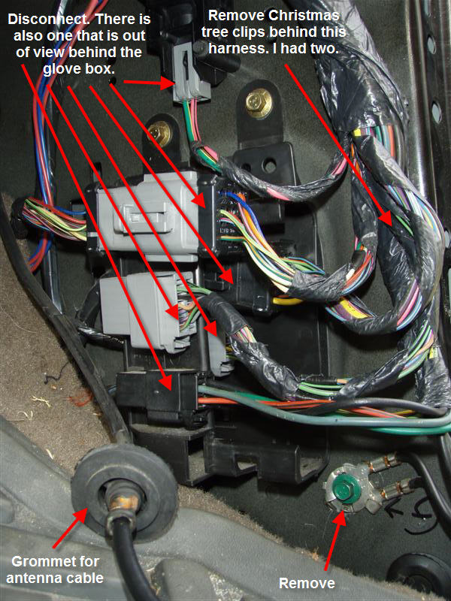

- Remove the steering column opening cover reinforcement and disconnect connectors.
  - Remove the 4 nuts (13 mm deep socket)
  - Remove the reinforcement
  - Disconnect the electrical connectors that are attached to the steering column. I had 3 that needed to be removed.
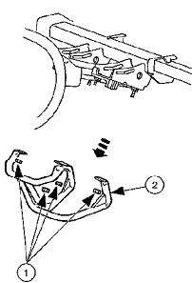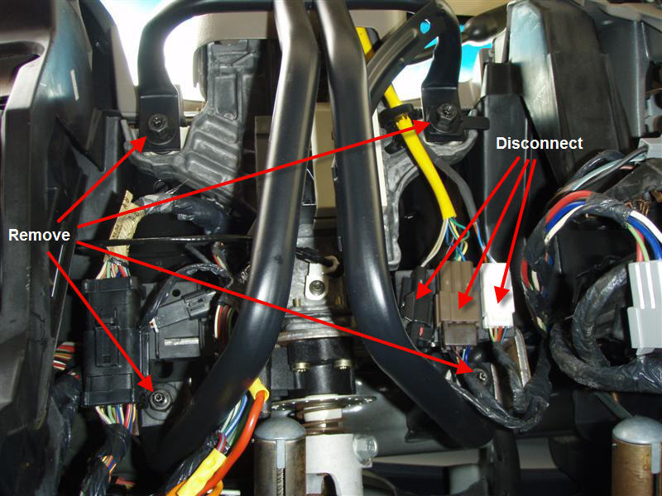

- If equipped, remove the transmission range indicator by remove the bolt and disconnecting the cable. NOTE: The cable is under tension and will recede into the cable housing when disconnected. Don’t worry; the cable will not disappear completely into the housing. You will still be able to reconnect it during reassembly.
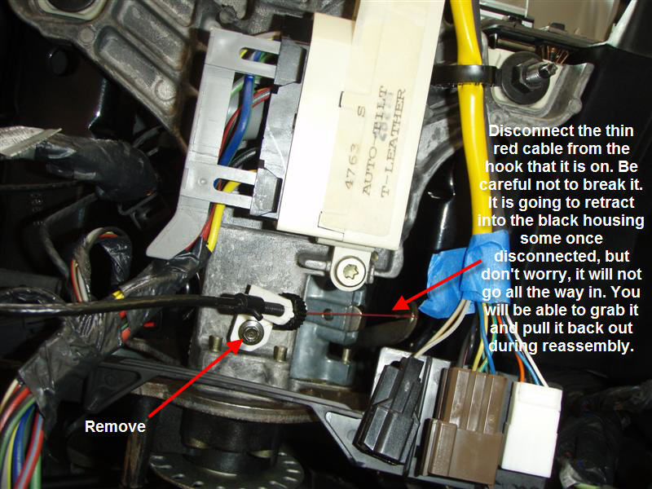

- Lower the steering column.
  - Remove the 4 nuts (13 mm) that hold the steering column in place. Completely remove the two that are closest to the engine compartment and remove the two that are closest to the steering wheel last. Make sure that you have a good grip on the steering wheel when you remove the last nut as the steering column will want to fall to the floor with all of the nuts removed.
  - Carefully and slowly lower the steering column to the floor. As you lower, pay close attention to any wires that may be interfering with the column as it is lowered. You don’t want to accidentally break, cut, or otherwise damage any of the wiring harnesses that are near it.
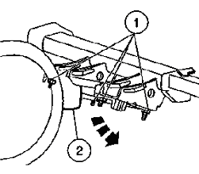
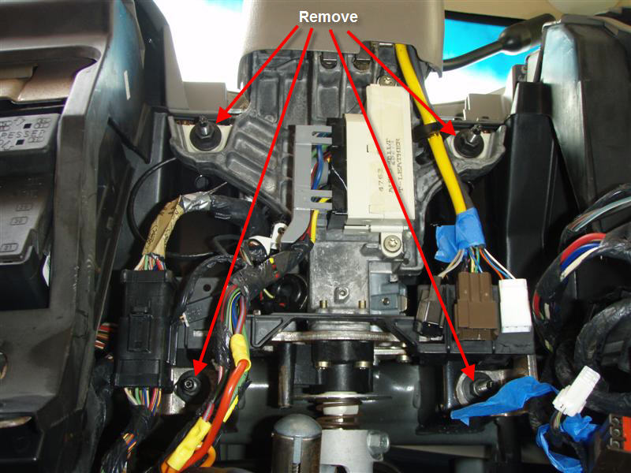

- Remove the instrument panel relay cover by carefully prying up on it. Be careful not to break any of the clips that hold it in place. There might be a couple of connectors under the panel. Disconnect them at this time. I had two that needed to be removed.
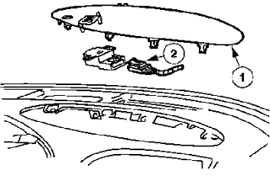
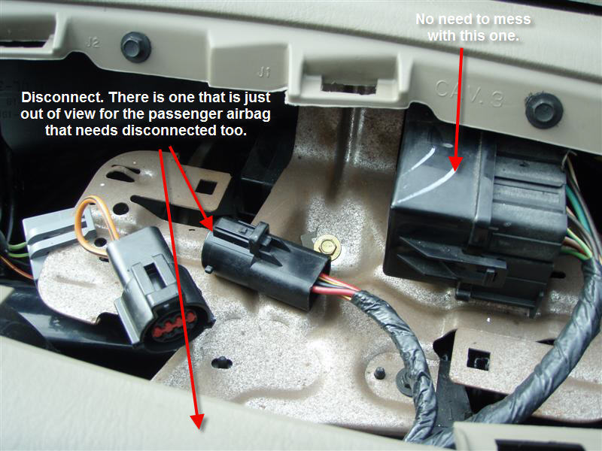

- Open the glove box and remove the door stops.
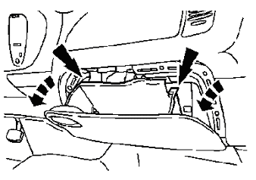
- Remove the passenger side airbag.
  - Remove the 3 screws
  - Unplug the electrical connector if you did not do so in step 21
  - Remove the airbag. Be careful when handling the airbag. I set this in a safe location far away from where I was working so that I would not do anything to accidentally set it off.
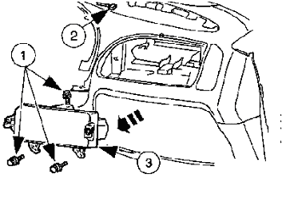
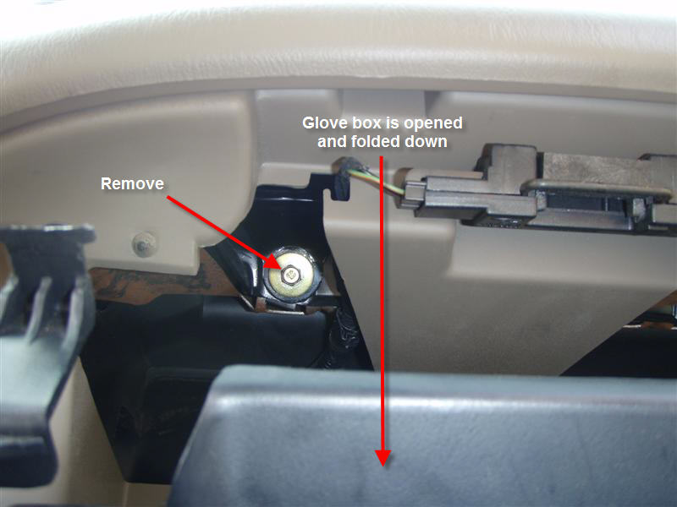
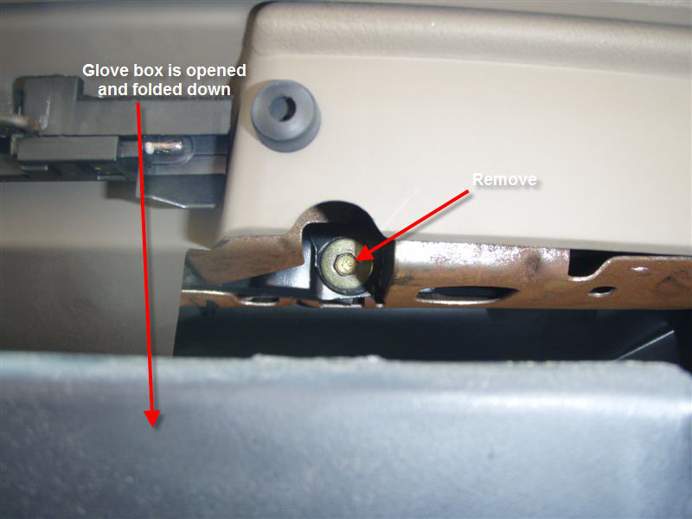

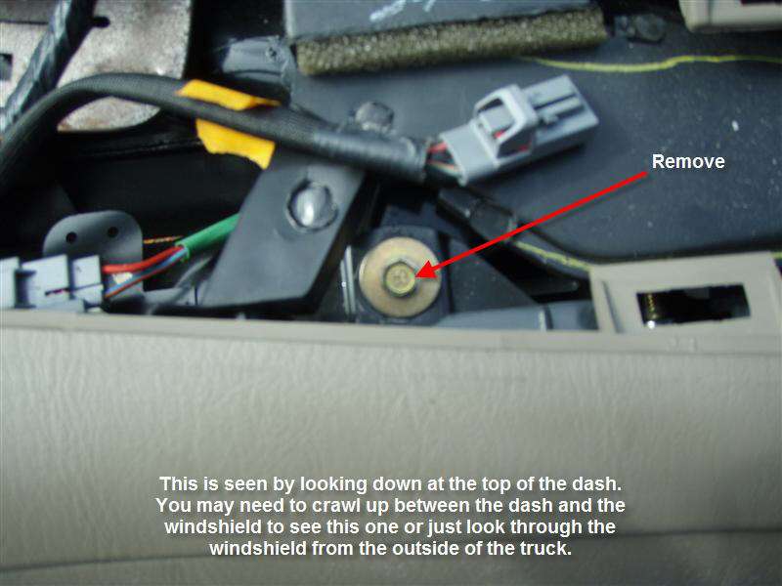

- Remove the instrument panel bolt to the lower left of the glove box.
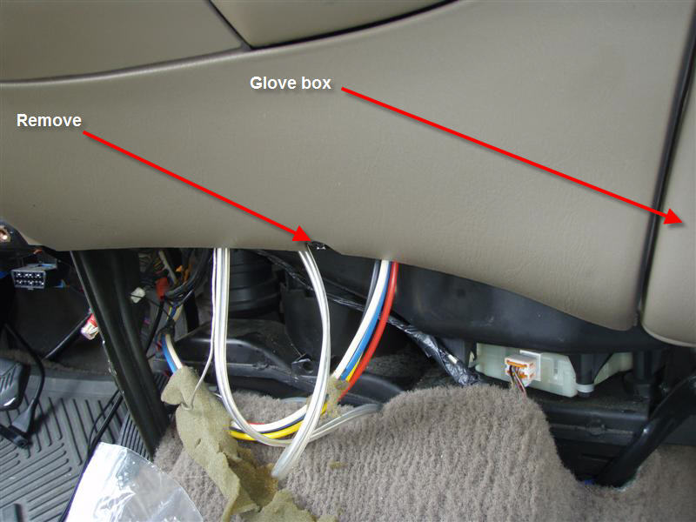

- Remove both instrument panel bolts behind the passenger side air bag module opening.
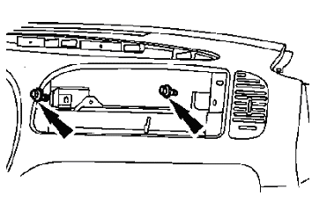
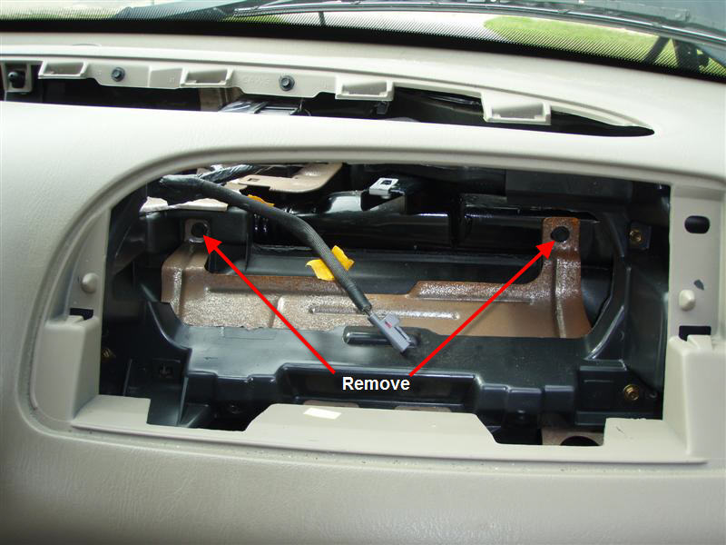

- Remove the instrument panel bolt on the relay bracket.
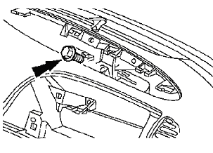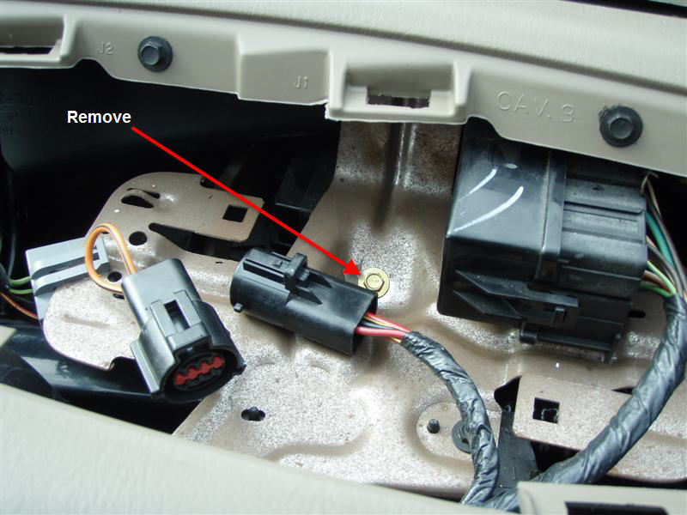

- Remove the two bolts below the cigarette lighter and power point.
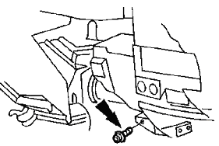
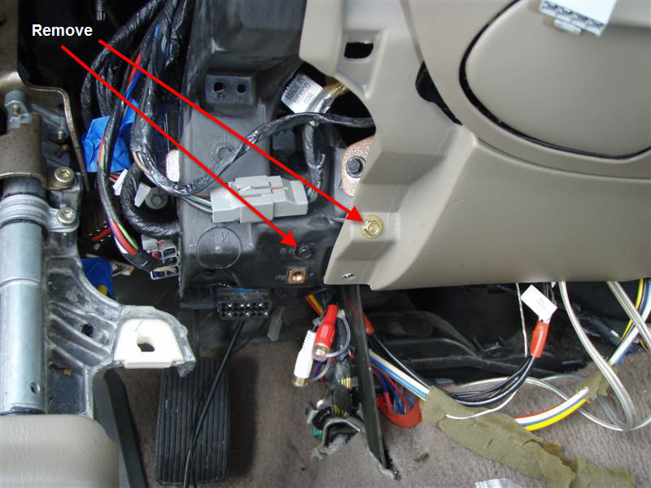

- Remove the 3 bolts around the instrument cluster opening; one on each side of the steering column and one just above the center of the steering column.

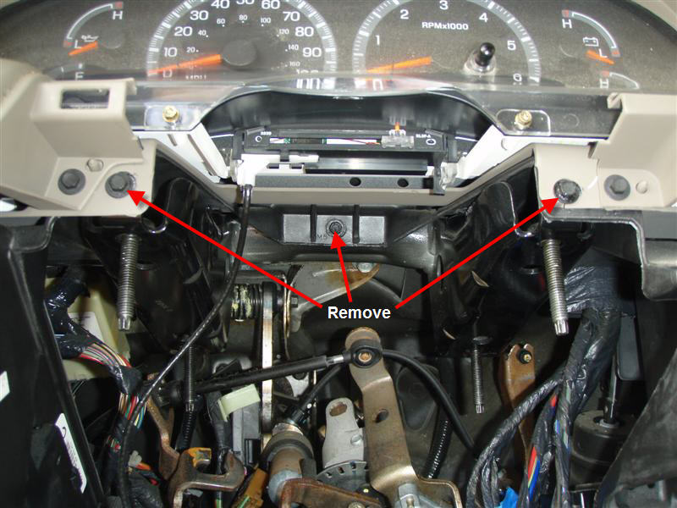

- Remove the bolt from the floor brace on the passenger side.
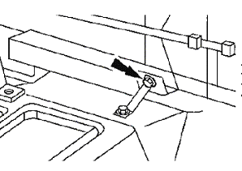
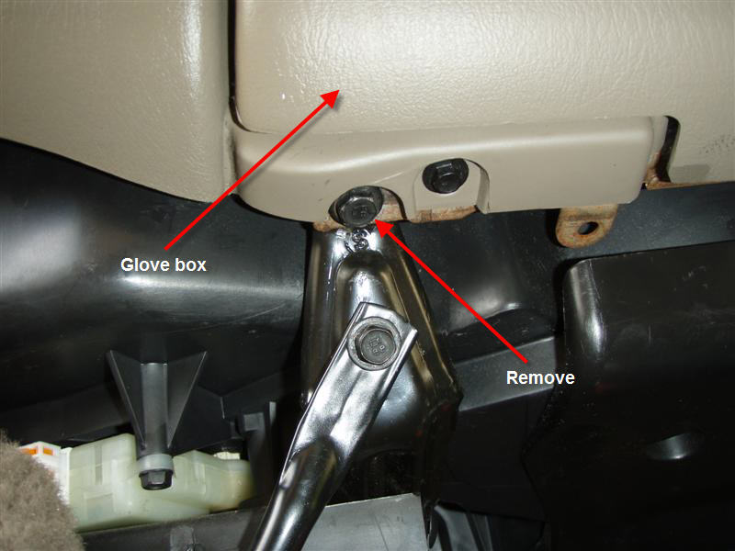

- Take a break. Have a glass of tea, finish that beer, have a smoke, or do whatever makes you feel relaxed. The next two steps should have your dash completely detached. If you have a friend helping… have them at the ready now.
- Remove the bolt from the lower left (driver side) of the dash. This will be the large bolt closest to the door. Removing the dash can be done by yourself, but if you have assistance, have the other person hold the dash from the driver side at this time.
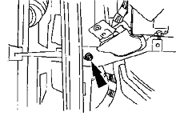
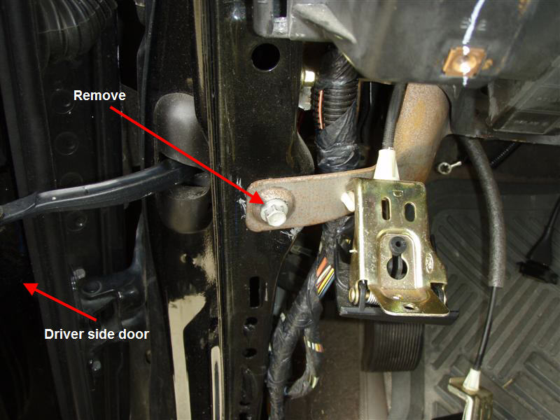

- Remove the nut from the lower right (passenger side) of the dash. This will be the larger nut closest to the door.
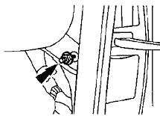
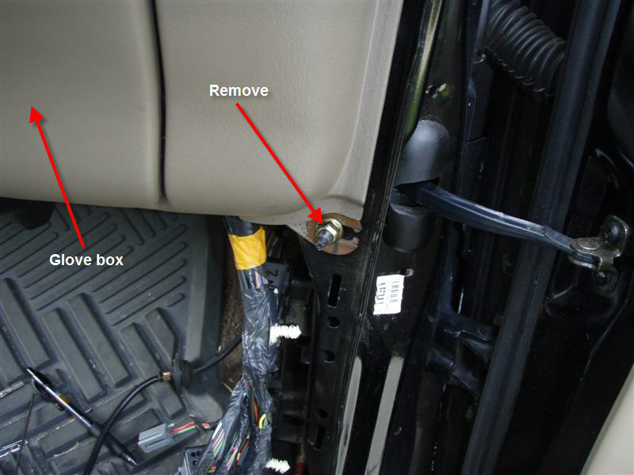

- At this time the dash should be completely detached.
  - Pull the passenger seat as far forward as you can
  - Gently wiggle the dash as you try to pull it away from the front of the truck. If you feel that it is still firmly attached then gently pull on the dash from various places to isolate the source of the resistance. Remove any remaining screws, bolts, etc. that are still holding the dash up. On the truck listed at the beginning of the document, there should be none left, but differing model years, trim packages, and aftermarket components may introduce something that is not covered here.
  - As you slowly remove the dash, look and feel for any resistance. If the dash can be removed, but starts to bind after a couple of inches then you most likely have a cable that is tight. Locate the source of the resistance and free it. It may be a simple connector that needs disconnected, a Christmas tree clip that needs pulled, etc.
  - Once you have the dash pulled free, the driver side dash should only be a foot or so out of its original position and the passenger side should be well clear of the windshield. You should be able to gently set the dash on the passenger seat to support it.

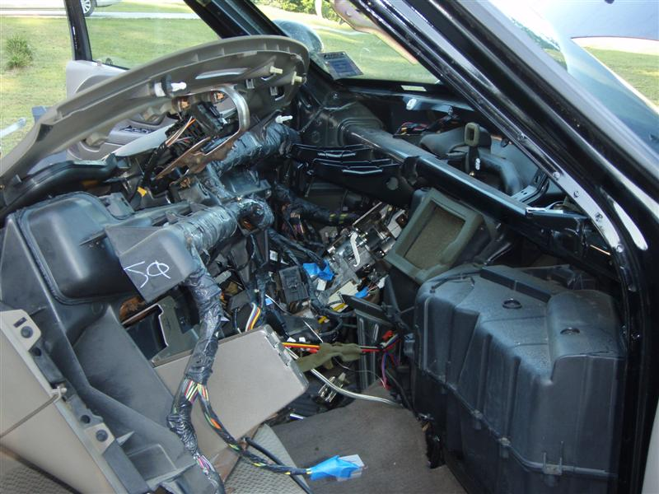

- There is a little hose that has a rubber clip on it. It simply slides into place into the top of the plenum. Remove it by sliding the rubber clip upward. Don’t disconnect the hose.

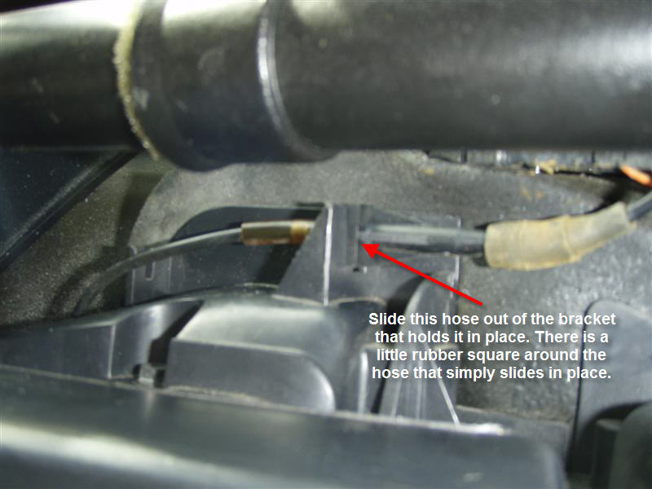

- The plenum cover is secured by many screws. I think that I had 15. Remove all of them and then remove the cover.

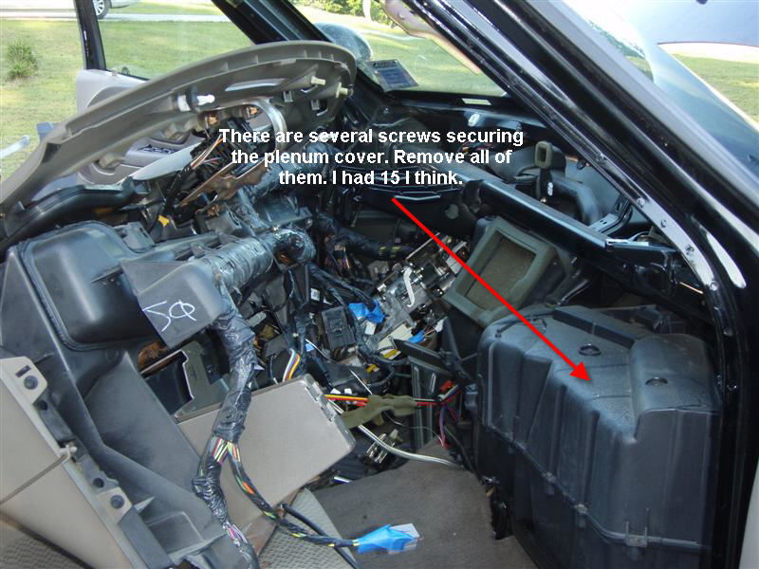

- The blend door and frame securing the blend door are positioned against the heater core. On the passenger side of the core you will see that the frame is simply clicked into place. Unclip the frame and gently lift the blend door and frame out of the plenum.
- If you have the special tool from Ford then use it now to disconnect the hoses. This will need to be done from within the engine compartment. If you did not get the tool then cut the inlet and outlet tubes on the old core now to remove it. I used a Dremel with a heavy duty cutoff wheel to get most of the way through. I finished the job with a small hacksaw blade. Be careful not to cut the line refered to in step 34 that is dangling just above these tubes!

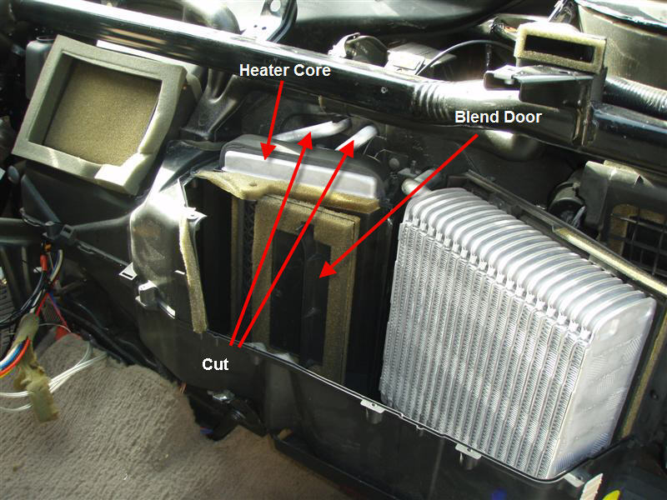

- In the engine compartment, pull the 2 hoses that were connected to the old core to pull the cut off tubes into the engine compartment. Each hose has a plastic clip securing it to a tube. Squeeze the tabs on the clip and remove the old tubes. Each tube should have a clip, a plastic ring, and 2 o-rings attached to it. If any of those items is missing then inspect the inside of the hose to see if they have remained in there and remove them if they are.
- Replace the heater core
  - Remove the old core from the plenum. It will just slide up and out.
  - Observe the wrapping of the foam tape on the old core and wrap your new core in a similar fashion.
  - Set the new core into place so that the inlet and outlet tubes extend through the firewall into the engine compartment.
- Replace the o-rings and clips by inserting them into each hose in the following order. Rubber o-ring, plastic ring, rubber o-ring, clip. Be sure that the clip locks into place on the hose.
- Replace the hoses by firmly pressing the clip onto the tube on the heater core. It will take a good amount of pressure. You will feel the clips lock into place on the heater core. Give each hose a tug to be sure that they are locked into place. It will help to have someone hold the heater core while you are pushing on each hose.
- Starting with step 36, work backwards until everything is reassembled. Don’t force the dash into place when you are placing it back in. Look at the dash closest to where it meets the windshield and you will notice several plastic tabs that fit into receiving holes below the windshield. These will help guide you to be sure that the dash is in the right position. Once you are sure that the dash is firmly in place then you can begin replacing the nuts, bolts, and screws that you have removed.

There you have it. You’ve just saved hundreds of dollars by doing it yourself.

